Stonecroft
HOA BOARD MEMBERS
John Rhomberg - 2022-2024
Becky Pogorzelski - 2021 - 2023
Jason Valero - 2023- 2025
Greetings from the HOA Board,
Annual HOA Board Meeting and Election – Our annual HOA Board meeting is scheduled for September 21st @ Kisker Library. Meeting will start at 5:00pm and will last approximately one hour. At the meeting, we will update you on minutes from the last meeting, review the current year and next year’s budget, and discuss any new business. In addition, we will be voting for the HOA Board. Becky’s term is up this year and has expressed interest in running for re-election. Please let us know if you are interested in serving on the HOA board. We’ll take a call for nominations at the meeting as well.
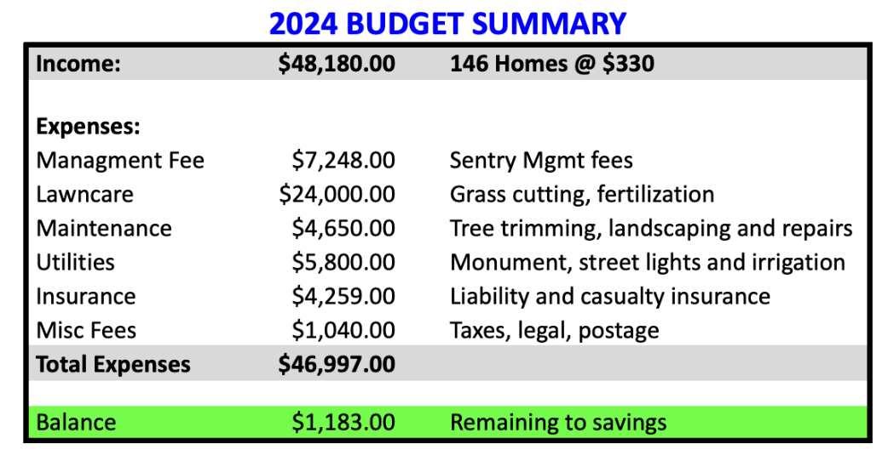
Budget - In 2023, we had projected HOA dues of $48K and expenses of $46K and are on track for the year. Good news is that everyone has paid their dues for 2023 in addition, all previous year outstanding dues have been collected as well. We are planning to keep the HOA dues at $330 which is the same as last year given that our expenses are expected to stabilize from last year’s increases. Please remember to pay your dues timely to avoid late fees and/or collection fees. If dues are not paid within 30 days of the due date, a late charge will be added. If they are not paid within 90 days, a lien notice will be sent and filed at 120 days. If the lien notice is filed, you will be responsible for paying for those fees as well.

Updates -

Thanks to the Fernandez family for putting on another great 4th of July fireworks display, the LaFiore’s for music this year and those that helped organize and clean-up afterwards. As this is not a neighborhood sponsored event, please remember you can help by showing your appreciation directly to Tom and the LaFiore’s.

Architectural Requests - Please remember to submit your requests for any work done to and around your house including fences, decks and pergolas before work starts. We don’t want to make the process cumbersome, yet provide you our approval before the work begins. We added a new page to the website where you can fill in the form and submit electronically without having to download…hopefully this makes the process easier.

We look forward to seeing you at the meeting and please send us a note with any comments. We can be contacted via the website using the contacts page or send an email to the address below. Also, join the subdivision Facebook site to see what’s happening with your neighbors.

Sincerely,
HOA Board

Neighborhood Website and Contact –
Website – www.StonecroftSubdivision.com - Community information and contact the HOA Board
Email - stonecroftsubdivision@gmail.com - Send an email directly to the HOA Board
Facebook – Stonecroft Subdivision - Be the first to know what’s happening and connect with your neighbors. Sentry Management –Tyler Mazdra, Community Association Manager 636-970-1887 (ext 57608)

